# Python3.11 site-packages

C:\Users\IGS\AppData\Roaming\Python\Python311\site-packages

# Download Dshell

git clone <https://github.com/USArmyResearchLab/Dshell>;

# Create a Python virtual env for Dshell to avoid conflicting modules with existing malicious tools

cd ./Dshell;

virtualenv venv_dshell;

# Directory will have venv_dshell come up

# Get into virtual environment (Linux)

source venv_dshell/bin/activate

# Get into virtual environment (windows)

source venv_dshell/Scripts/activate;

# Install dependencies in venv_dshell

pip install pygeoip pycryptodome dpkt ipy pypcap;

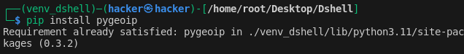

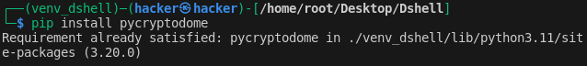

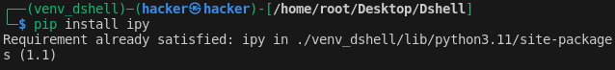

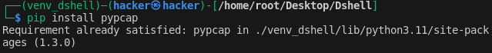

# If need to exit virtual env

deactivate;

# Exit virtual environment && Use decode.py

cd Dshell/dshell;

python3 decode.py;

python3 decode.py -l;

